Google Analytics in AN CUI

Revision History

|  |  |  |
| --- | --- | --- |
| Date | Author | Content |
| 10/09/2014 | Leon Chen | Initial draft version. |
|  |  |  |

Contents

Basic Concepts 3

What is GA? 3

How to integrate with GA? 3

Check the tracking code set up correctly 3

Universal Analytics 4

Advanced Development on GA 5

How Google Analytics Works 5

Cross Domain Tracking 5

Official Reference Document 6

Google Analytics (ga.js) – AN CUI is using this 6

Universal Analytics (analytics.js) 6

GA in ActiveNet CUI 6

Tracking code in CUI 6

Settings on AUI 7

# Basic Concepts

## What is GA?

Google Analytics is a service offered by Google that generates detailed statistics about a website's traffic and traffic sources and measures conversions and sales. It's the most widely used website statistics service.

Google Analytics can track visitors from all referrers, including search engines and social networks, direct visits and referring sites. It also tracks display advertising, pay-per-click networks, email marketing and digital collateral such as links within PDF documents.

*Ref:* [*http://en.wikipedia.org/wiki/Google_Analytics*](http://en.wikipedia.org/wiki/Google_Analytics)

## How to integrate with GA?

Generally, GA needs the website to integrate a JS tracking code snippet so it can trace the website’s traffic using it.

1. Apply a Google Analytics account.
2. Get the GA JS tracking code snippet from GA app control panel.  
   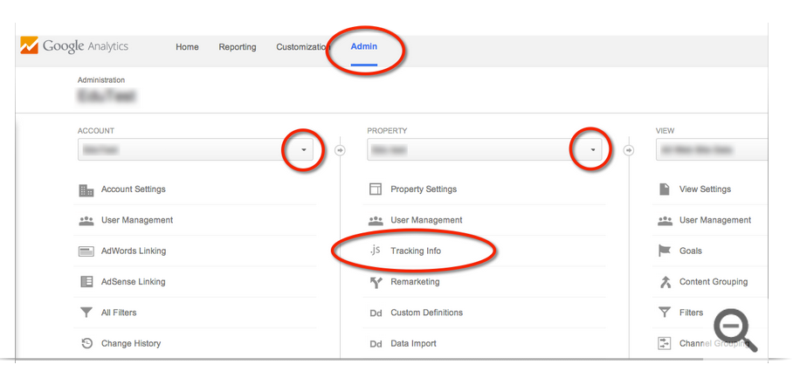
3. Copy the JS code to the HTML pages you need GA to track. It should be in the <head> tag.
4. Set in GA app control panel for the report you need to get.
5. The analytics report will take effect after 24 hours.

*Ref:* [*https://support.google.com/analytics/answer/1008080*](https://support.google.com/analytics/answer/1008080)

## Check the tracking code set up correctly

Following the 4 steps to check if the tracking code is working:

1. Check the source code of the website page to see if there is GA JS coding in it with correct property number.
2. In the GA account you can see the Tracking Status that indicates if the tracking code work or not.

Status:

* Waiting for Data  
  The tracking code has been detected on the homepage of your website, and the Google Analytics servers are updating your configuration before your data can be processed and appear in your reports.
* Tracking Not Installed or Not Verified  
  The tracking code isn’t set up correctly on your webpages.
* Tracking Installed  
  You’ve got the tracking code set up, and it’s collecting and sending data to your property.
* Unknown  
  There's no data available that Google Analytics can use to tell if your tracking code is working. Check your set up to see if you can find a solution.

1. Check the Real-Time reports in GA account  
   With the Real-Time reports, you can monitor user activity as it happens. If you see data in these reports, it means that your tracking code is currently collecting data.
2. Install and use the Google Analytics Debugger extension for Chrome.   
   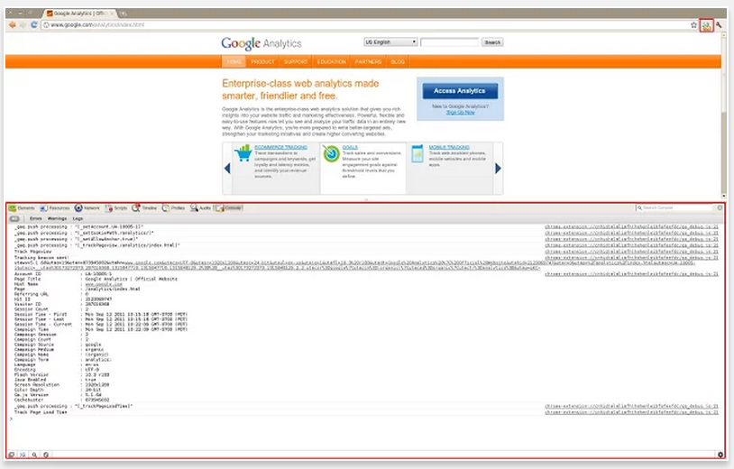

*Ref:* [*https://support.google.com/analytics/answer/1008083*](https://support.google.com/analytics/answer/1008083)

## Universal Analytics

Universal Analytics is the upgrade of classic Google Analytics.

The most rapid and easiest way to tell whether Universal Analytics or Google Analytics is used is to check the web tracking JS code: Google Analytics uses ga.js while Universal Analytics uses analytics.js.

*For technical details to upgrade from GA to UA, ref:* [*https://developers.google.com/analytics/devguides/collection/upgrade/reference/gajs-analyticsjs*](https://developers.google.com/analytics/devguides/collection/upgrade/reference/gajs-analyticsjs)

# Advanced Development on GA

## How Google Analytics Works

GA is based on the JavaScript website analytic:

When a visitor visits a page installed tracking JS code, the web browser sends two HTTP requests:

* Based on the URL to access the web server (abc.com). This HTTP request takes Cookies under domain abc.com (1st party Cookie)
* After the page is returned from server and finish loading on the browser, the tracking JS code runs. It gets the refer, 1st party Cookie, 3rd party Cookie and other information, packages with the HTTP request and sends to GA server.

*For more technical details about the cookies GA uses, Ref:* [*https://developers.google.com/analytics/devguides/collection/analyticsjs/cookie-usage*](https://developers.google.com/analytics/devguides/collection/analyticsjs/cookie-usage)

## Cross Domain Tracking

A default setup of Google Analytics is designed to track content and visitor data for a single domain. By customize the tracking code it also can track:

* Subdomains - all visitors to both dogs.example.com and www.example.com, with data for both showing in the same report view (profile)
* Subdirectories - only visitors to the www.example.com/dogs subdirectory in a separate report as if it were a single site
* 3rd-party shopping carts - visitors to your online store and to your shopping cart hosted on another domain
* Top-level domains - all visitors to two domains that you own, such as www.example-petstore.com and www.my-example-blog.com, with data for both showing in the same report view (profile)
* IFramed Content - visitor and pageview data for content in an iFrame of another domain.

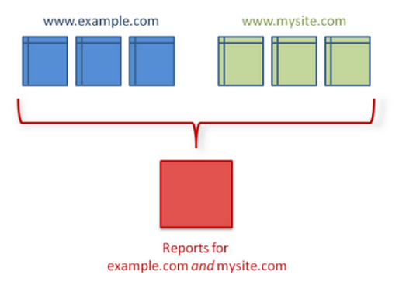

About how GA works for domains & dictionaries, Ref: [*https://developers.google.com/analytics/resources/concepts/gaConceptsDomains*](https://developers.google.com/analytics/resources/concepts/gaConceptsDomains)

Key Points:

1. GA uses document.domain to define a site.
2. Separate domains mean separate user and traffic data even they are using a same web property
3. Separate domains do not mean separate content
4. In default setting, user, traffic, and campaign data to the subdirectory will be shared with user, traffic, and campaign data across the entire website

## Official Reference Document

### Google Analytics (ga.js) – AN CUI is using this

*Ref:* [*https://developers.google.com/analytics/devguides/collection/gajs/*](https://developers.google.com/analytics/devguides/collection/gajs/)

### Universal Analytics (analytics.js)

*Ref:* [*https://developers.google.com/analytics/devguides/collection/analyticsjs/*](https://developers.google.com/analytics/devguides/collection/analyticsjs/)

# GA in ActiveNet CUI

## Tracking code in CUI

AN CUI is using classic Google Analytics (ga.js). There is a utility class to generate GA tracking codes: ACM.Utility.GoogleAnalyticsBuilder. It is used on base page CustomContentPageBase.

According to the following GA settings on AUI, it adds the GA tracking code to the CUI site using method BuildScript().

## Settings on AUI

Administration -> System Settings -> Configuration - Online

